Practical No 5
Loop based Programs
Aim: Write a Python program to demonstrate Looping.
while loop
- Print Numbers from 1 to 10

Code:
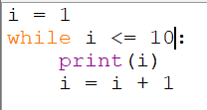

Output:
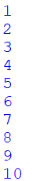

- Print Numbers from 10 to 1

Code:
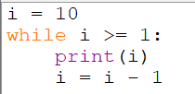

Output:
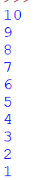

- Print Even Numbers from 1 to 20.

Code:
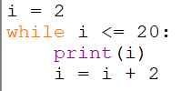

Output:
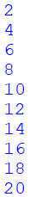

- Print Odd Numbers from 1 to 20

Code:
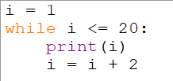

Output:
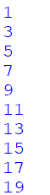

- Find the Sum of First 10 Natural Numbers

Code:
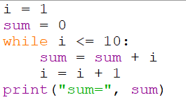

Output 1:
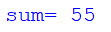

- Display the Multiplication Table of a Number

Code:
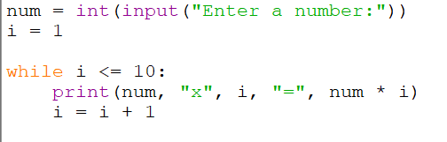

Output:

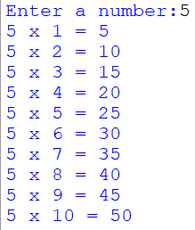
- Count the Number of Digits in a Number

Code:
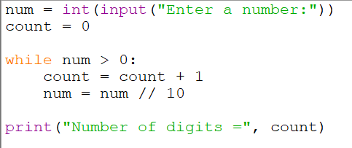

Output:
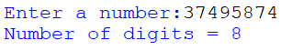

- Reverse a Number

Code:
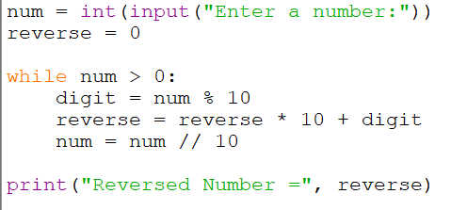

Output:
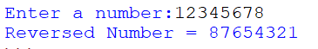

- Check Whether a Number is a Palindrome

Code:
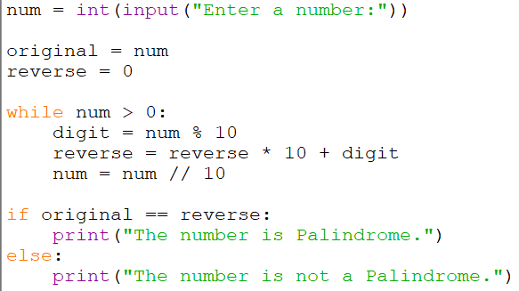

Output 1:
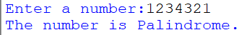

Output 2:
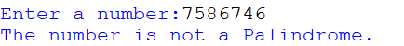

- Find the Factorial of a Number

Code:
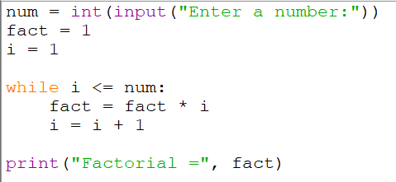

Output:
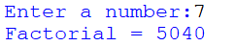

- Program to generate Fibonacci series

Code:
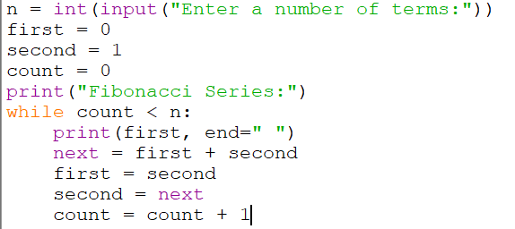

Output:


